RINGS-A000-EUR-Italy-Rome- Legio III Italica

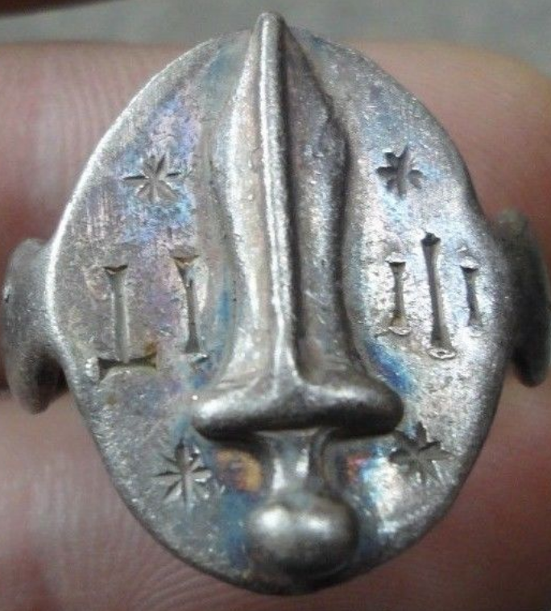

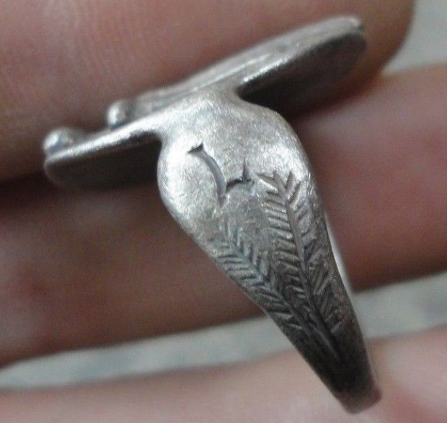

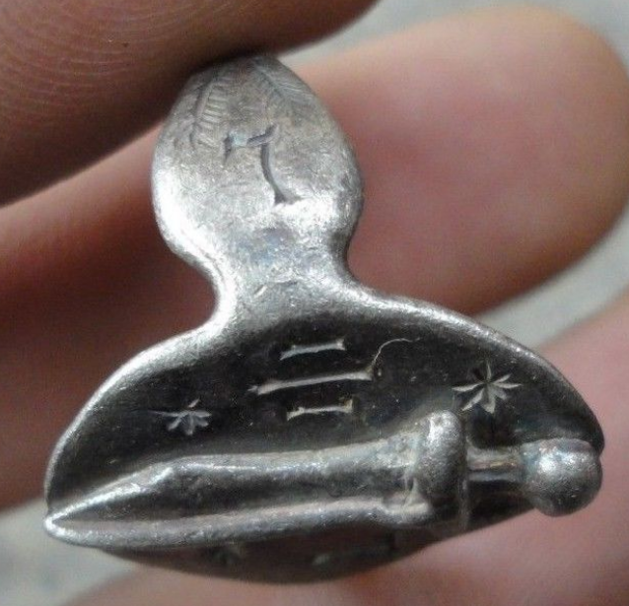

**Legio III Italica**

**Legio III Italica - Legio tertia Italica ("Italian Third Legion") was a legion of the Imperial Roman army founded in AD 165 by the emperor Marcus Aurelius (r. 161-80), for his campaign against the Marcomanni tribe. The cognomen Italica suggests that the legion's original recruits were mainly drawn from Italy. The legion was still active in Raetia and other provinces in the early 5th century (Notitia Dignitatum, dated ca. 420 AD for Western Roman Empire entries). Together with legions II Italica and I Adiutrix, III Italica legion was in the Danube provinces from its beginning, fighting the Marcomanni invasion of the Raetia and Noricum provinces. In 171 they built the camp Castra Regina, present Regensburg, designed as strongly defensive position. In the civil war of 193, this legion supported Septimius Severus and helped him defeat his opponents: first Didius Julianus, then Pescennius Niger and Clodius Albinus. Their loyalty was extended to Severus' successor, emperor Caracalla, for whom they fought in 213 a campaign against the Alamanni.**

INSCRIBED - ROMAN LEGIONARY COMBAT SWORD / Gladius / Pugio / Dagger  - L - III - IT

EXTREMELY RARE **Roman SENATORIAL LEGIONARY SILVER ring.**

SOLID SILVER - Wearable <> 8.10 grams <>

**<> 21.00mm. = 0.84" Inner diameter <>**